

Visual Programming
Lab Mid
SUBMITTED BY:
UBAID AHMAD
ROLL NO:
2410-0011
SUBMITTED TO:
Sir Aaish Khan
DATE:
03/11/2026

Task 1
- Create a class with an array of of primeNumbers
- A function for generating the primeNumbers and adding them to the array
- A function for displaying the primeNumbers Generated
Code:
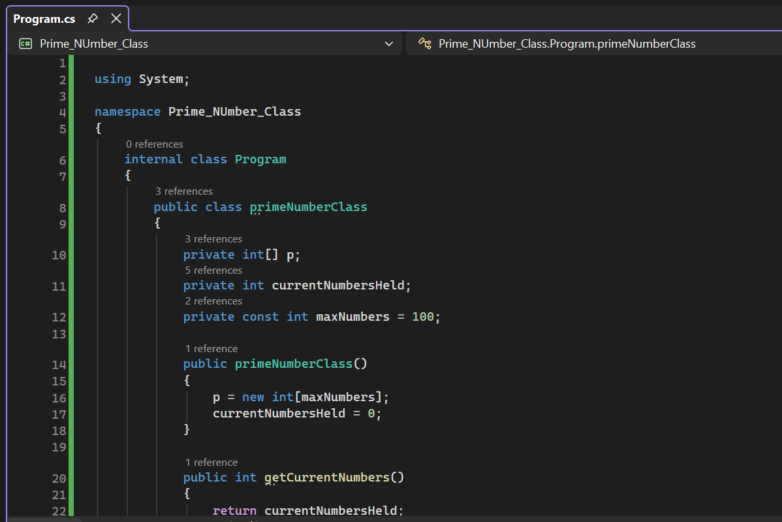
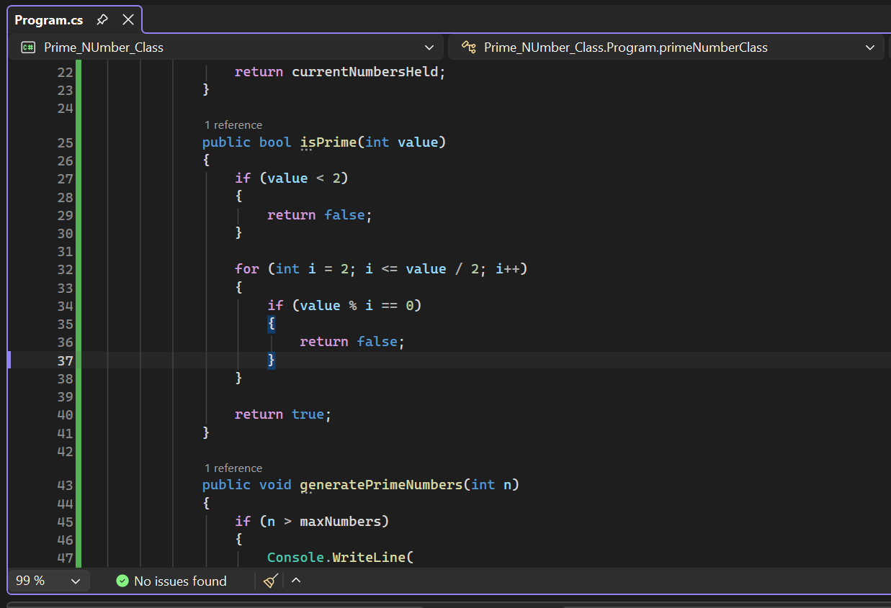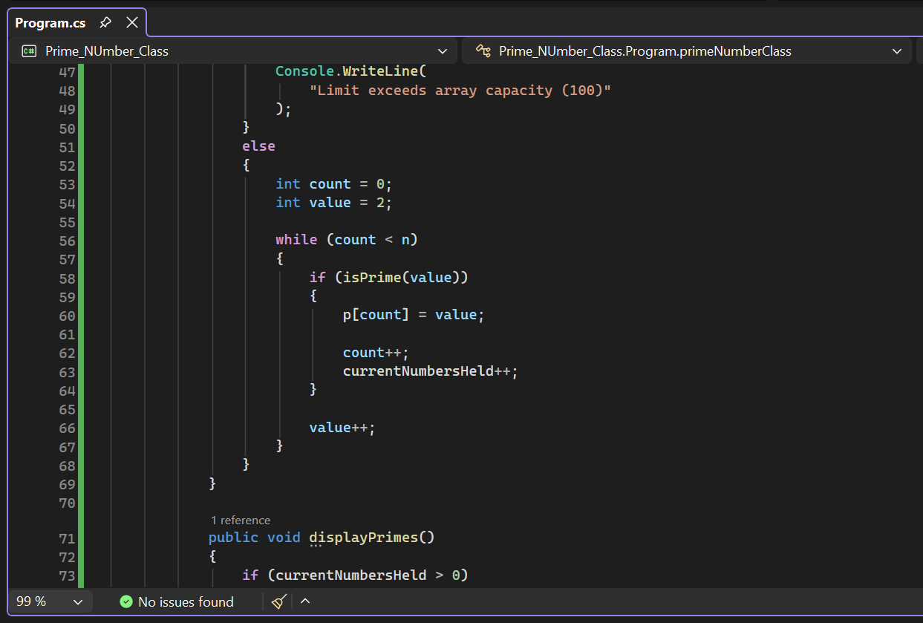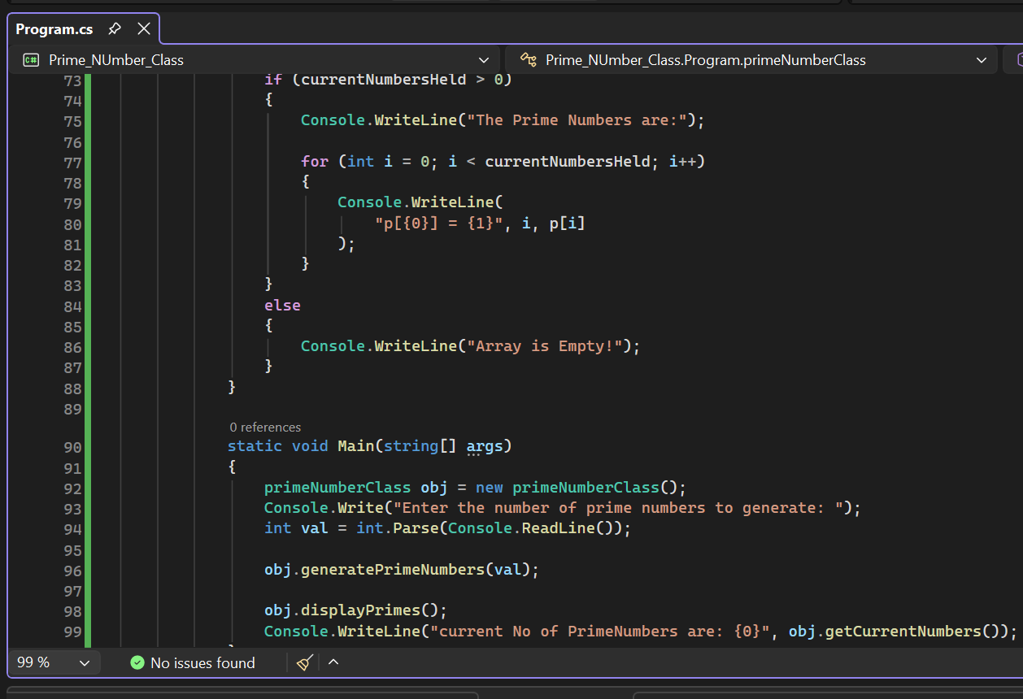

OUTPUT:
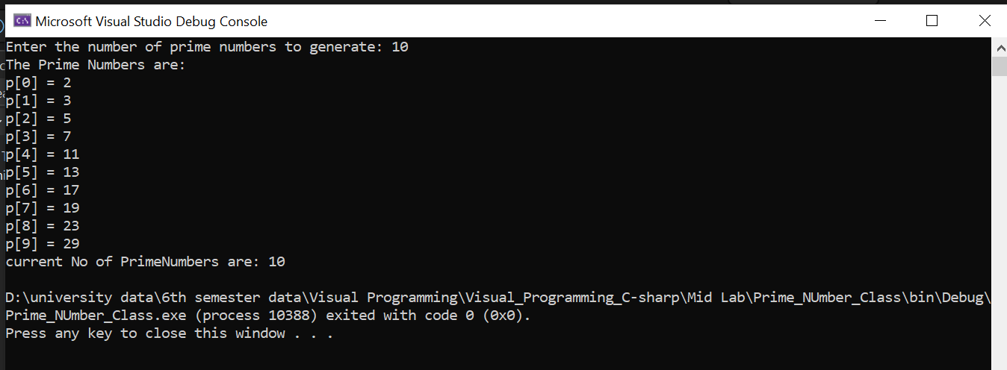

Task #2:

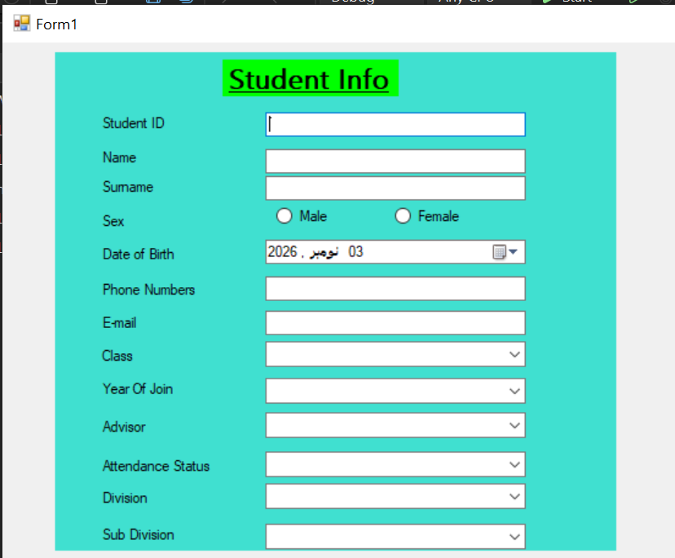
Drop Down for Class:
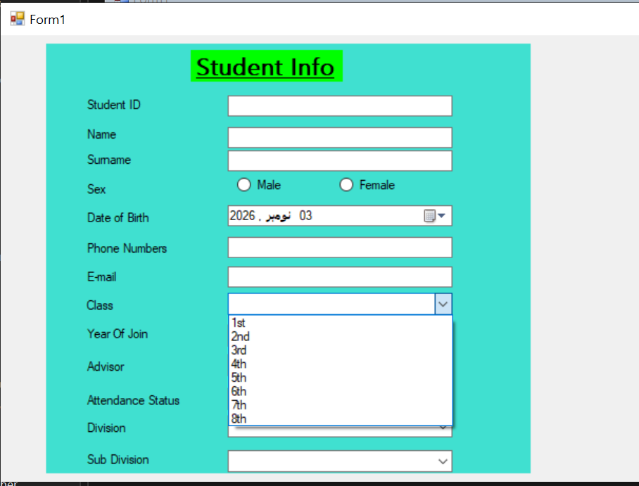

Year of join dropdown:
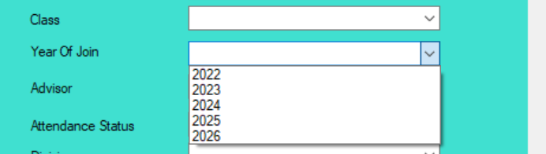

Validation:

Name and ID Va;lidation if empty:
Couldn’t name the textboxes properly due to time shortage:
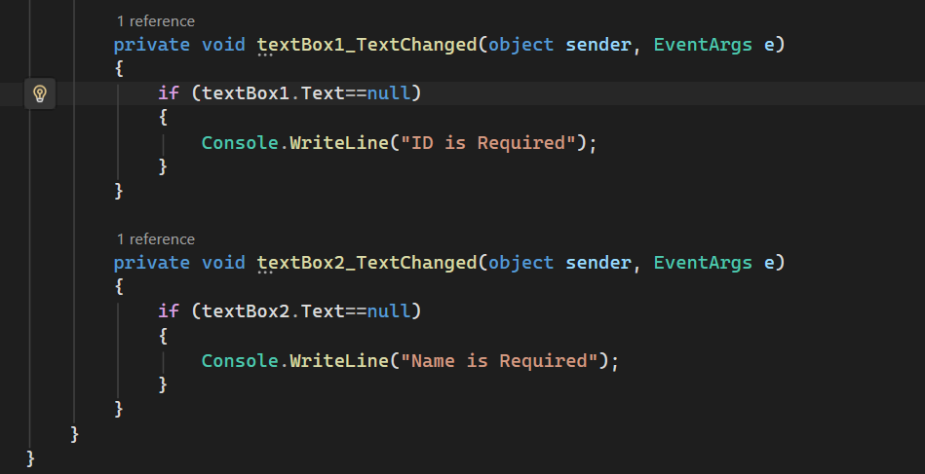
Email Validation:
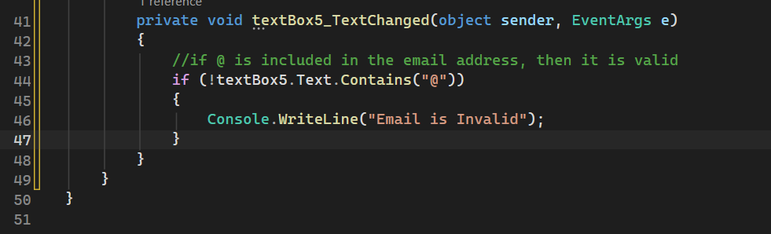

END:

